**File naming conventions and evidence**

Naming conventions

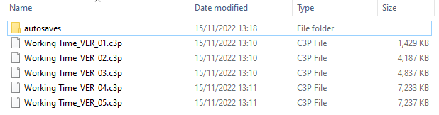

Above I saved all versions in the format: Name_VER_(version number)

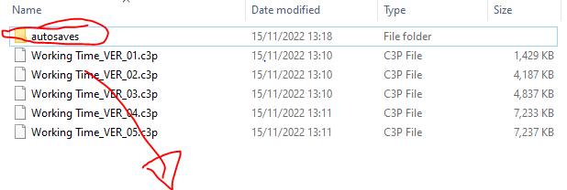

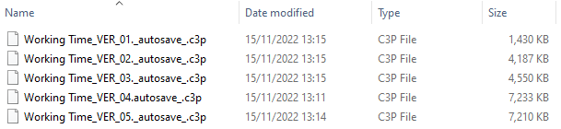

While I was working I used the auto save feature in construct 3 in case anything happened to the standard copies:

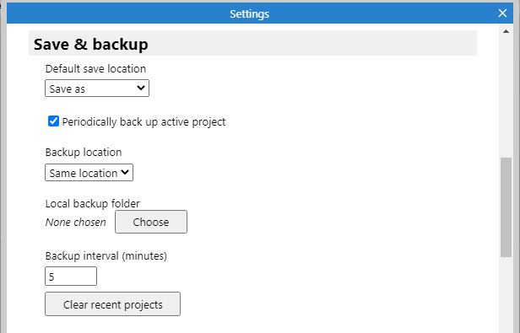

I also used the online save feature via google drive so I could work at home:

